Sprint 3 - Agility Design Document

Executive Summary 3

* 1. Project Overview 3
  2. Purpose and Scope of this Specification 3

1. Product/Service Description 3
   1. Product Context 3
   2. User Characteristics 3
2. Assumptions 3
3. Constraints 3
4. Dependencies 4
5. Requirements 4
6. Functional Requirements 4
7. Security 5
   1. *Protection 5*
   2. *Authorization and Authentication 5*
8. Portability 5
9. Requirements Confirmation/Stakeholder sign-off 5
10. System Design 5
    1. Algorithm 6
11. System Flow 6
12. Software 6
13. Hardware 6
14. Test Plan 6
15. Task List/Gantt Chart 6
16. Staffing Plan 6

**Executive Summary**

***Project Overview***

**Describe this project or product and its intended audience, or provide a link or reference to the project charter.**

The idea of this project is to use our coding and software engineering skills to control a robot, and make the robot follow the steps that were provided. This is intended to reach the audience of the rest of our class and professor Eckert.

**Purpose and Scope of this Specification**

The purpose of this project is to have our robot complete an obstacle course while doing so our robot must avoid the objects in the way, complete a ramp jump and knock down as many pins as possible. It will be presenting its agility to professor Eckert. All of the instructions for the robot to complete the activity correctly will be listed within the scope

**Product/Service Description**

The general factors that affect the product and its requirements are the code that we use. As well as the objects that we must avoid, and the ramp that our robot must go over. Lastly it is affected by the robot itself and how it is calibrated before each test run.

***Product Context***

To operate our robot and get it to follow precise directions, we use the Sphero coding system. The Sphero robot is distinct from other robotics devices due to its spherical form and sophisticated programming capabilities. Sphero is an independent device that runs on its own. Because Sphero is compatible with many related systems, users can code and operate the robot with great flexibility by utilizing Bluetooth connectivity to interface with smartphones, tablets, and other devices. The spherical body of Sphero, along with its internal sensors, motors, and programmable interface—all of which work together to provide control and communication—are its main constituents.

***User Characteristics***

There will be three of us working on the project. We are all new to coding and have used the Sphero system only 1 or 2 times before. Hopefully we can learn the best way to use Sphero by doing the project and learn as we go along.

***Assumptions***

* Inserting inaccurate speed into block code
* Inserting inaccurate distance into block code
* Inserting inaccurate angles into block code
* Not having access to the room
* Tables and chairs interfering with robot
* Damaged equipment
* Sphero, laptop, or smartphone out of battery

***Constraints***

* Room availability
* Due date
* Resources
* Obstacles in the course

***Dependencies***

* Code must be written in block
* Code must be completed for the robot to run
* Room must be available
* Robot must be charged
* Phone and laptop must be charged
* Robot and bluetooth must be working properly

***Indurance***

1. There will be a piece of tape on the floor of the classroom that the robot must follow

2. We will begin by placing the robot at the starting point

3.Once placed on the starting point the robot will begin

4. It will roll at 100 speed for 1.2 seconds

5. It will then delay for 2 seconds

6. It will roll 90 degrees at the speed of 100 for 1.5 seconds

7. It will delay 2 seconds

8. It will then roll at a speed of 100 for 1.8 seconds

9. It will delay 2 seconds

10. It will then roll at an 88 degree angle at a speed of 255 for 1.9 seconds

11. It will delay 2 seconds

12. Lastly it will roll at a 221 degree angle for 3 seconds at a speed of 255

***Functional Requirements***

| Req# | Requirement | Comments | Priority | Date Rvwd | SME Reviewed / Approved |
| --- | --- | --- | --- | --- | --- |
| 1 | There will be a figure an course our robot must follow it must avoid the bottles and complete the ramp jump | The robot often hits the bottles and the robots calibration is sometimes altered by the ramp jump |  | 12/1/23 | Approved |
| 2 | The robot must be calibrated at the start point | Meets requirements |  | 12/1/23 | Approged |
| 3 | Robot will roll 0 degrees at a speed of 100 for 1.2 seconds | Meets requirements |  | 12/1/23 | Approved |
| 4 | The robot will delay 2 seconds | Meets requirements |  | 12/1/23 | Approved |
| 5 | The robot will then make a -90 degree turn at a speed of 100 for 1.5 seconds | Meets requirements |  | 12/1/23 | Approved |
| 6 | The robot will delay 2 seconds | Meets requirements |  | 12/1/23 | Approved |
| 7 | The robot will roll at a 0 degree angle for 1.8 seconds at a speed of 100 | Meets requirements |  | 12/1/23 | Approved |
| 8 | The robot will delay 2 seconds | Meets requirements |  | 12/1/23 | Approved |
| 9 | The robot will roll at an 88 degree angle for 1.9 seconds at a speed of 255 | Meets requirements |  | 12/1/23 | Approved |
| 10 | The robot will delay 2 seconds | Meets requirements |  | 12/2/23 | Approved |
| 11 | The robot will roll 221 degrees for 3 seconds at a speed of 255 knocking down as many pins as possible | Meets requirements |  | 12/2/23 | Approved |

***Security***

***Protection***

There is one person who is in sole possession of the robot. They are not allowed to give it to any other group members to prevent losing it or miscommunications. The person who possess the robot signed off on it to ensure they do not lose it and are in full responsibility

***Authorization and Authentication***

In order to access the Sphero app you must have a device that is compatible and you must have an account.

**Portability**

| **Meeting Date** | **Attendees (name and role)** | **Comments** |
| --- | --- | --- |
| **11/31** | Salvatore, David, Deuce | **confirmed all** |
| **12/1** | Salvatore,David,Deuce | **confirmed all** |
| **12/2** | Salvatore,David,Deuce | **confirmed all** |
| **12/3** | Salvatore,David,Deuce | **confirmed all** |

***System design***

***Algorithm***

* Place the robot on the starting point
* Robot is calibrated to roll straight forward
* It will roll at 100 speed for 1.2 seconds
* Robot then delays for 2 seconds
* Robot rolls 90 degrees at a speed of 100 for 1.5 seconds
* Robot then delays for 2 seconds
* Robot rolls 0 degrees at a speed of 100 for 1.8 seconds
* Robot then delays for 2 seconds
* Robot rolls at an 88 degree angle for 1.9 seconds at a speed of 255
* Robot then delays for 2 seconds
* Robot rolls at a 221 degree angle for 3 seconds at a speed of 255
* Robot stops

***System Flow***

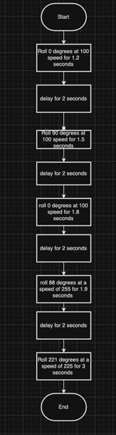

***Software***

Describe software languages/platforms/api’s used to develop and deploy this application. Embed your block code hereere

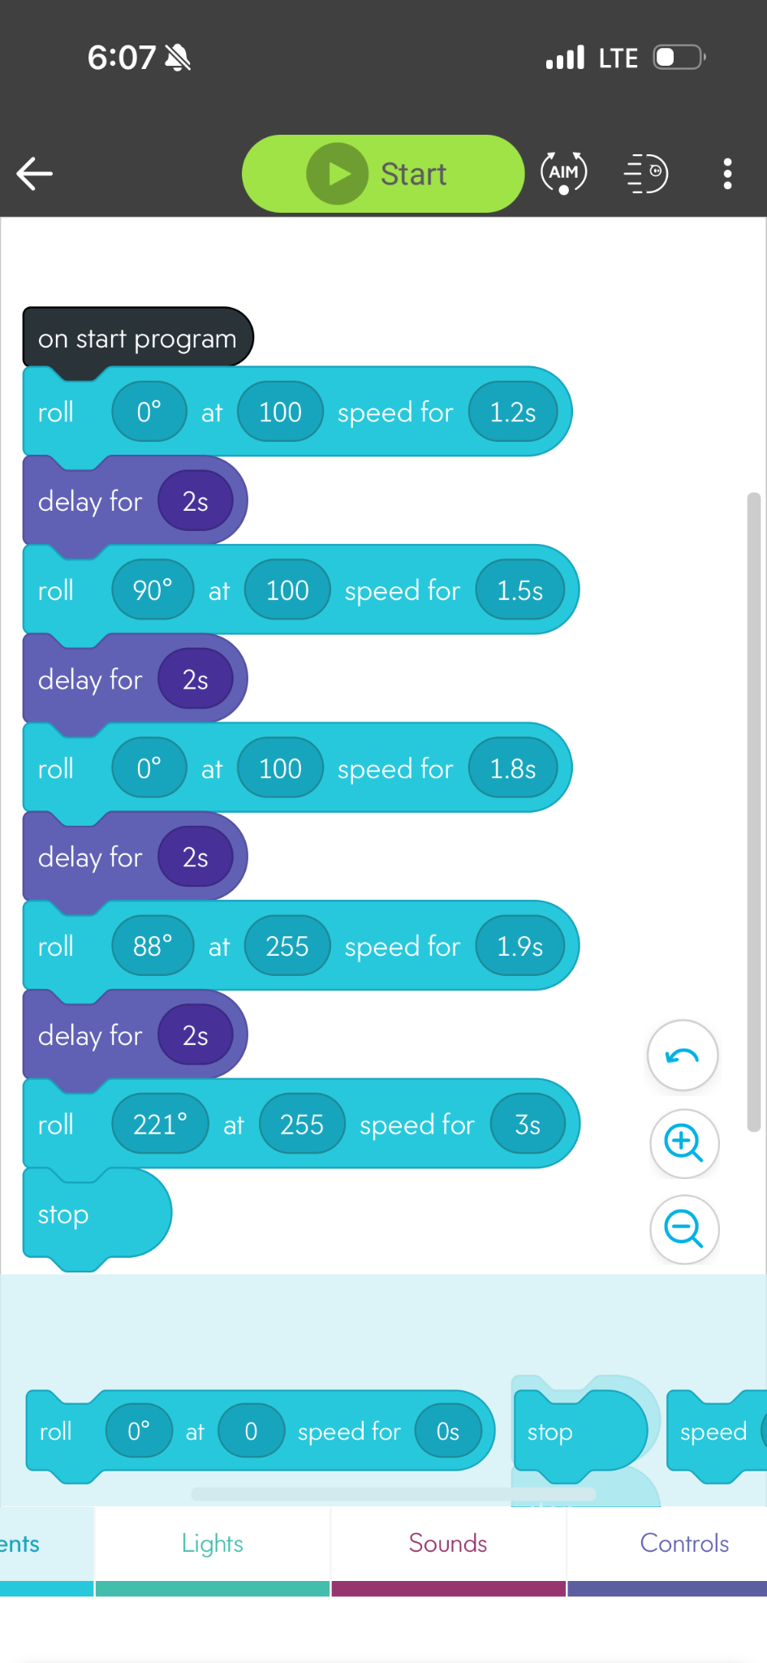

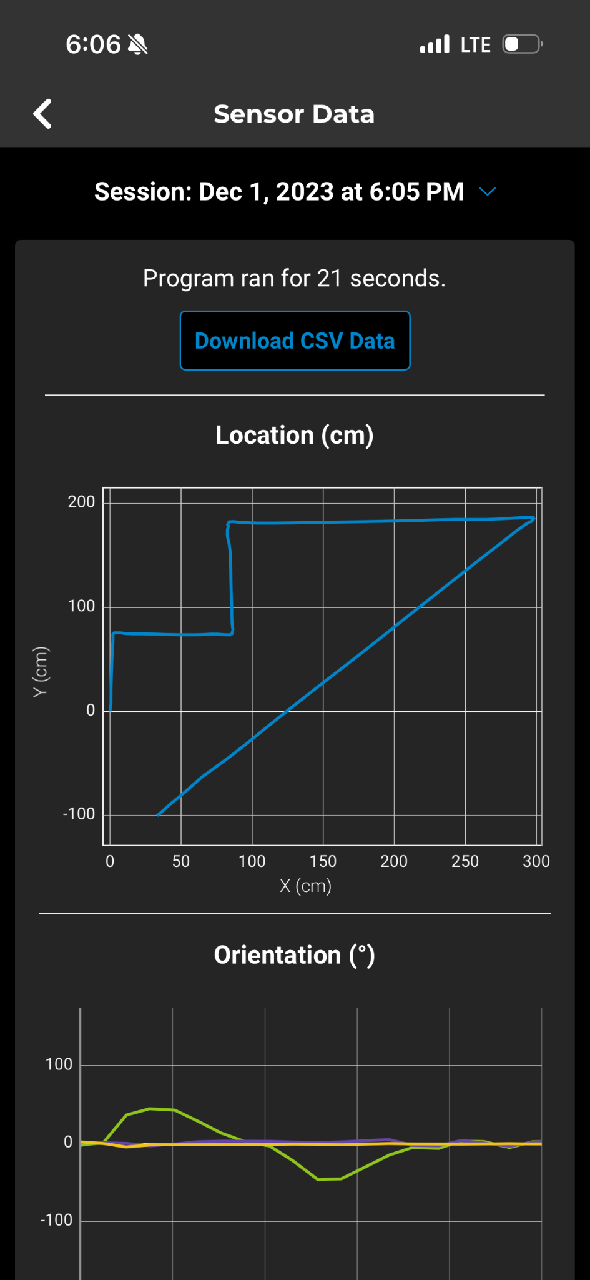

***Hardware***

Laptops and phones were used

***Test Plan***

Include a test plan showing all unit tests performed for this application, Include test rational, test date, staff member, pass/fail status

| **Reason for Test Case** | **Test Date** | **Expected Output** | **Observed Output** | **Staff Name** | **Pass/Fail** |
| --- | --- | --- | --- | --- | --- |
| To test our initial code | 12/1/23 | To complete the first straight line | Followed the line well | Sal | Pass |
| Test to make sure the robot does not hit the obstacle | 12/1/23 | The robot to avoid obstacle and stay in line | Turned to wide hit the obstacle | Deuce | fail |
| Test angle 90 for turn | 12/1/23 | The robot to avoid obstacle and stay in line | Worked well | David | Pass |
| Delay 2 seconds | 12/1/23 | To make a circle going in the opposite direction to make an 8 | Worked well | Deuce | pass |
| Test how robot bot would be affected by the ramp jump | 12/1/23 | The robot would stay online if collaborated correctly initially | Was minorly disorientated but stayed on line and was able to hit the pins | David | pass |
| See how many pins it could knock down in on try at a speed of 255 | 12/1/23 | Expect to knock down all pins | Knocked down 4 pins | Sal, Deuce Daviud | pass |
| Stop presentation | 12/1/23 | The robot to stop | Stopped after 3 seconds | Sal, Deuce Daviud | Pass |
|  |  |  |  |  |  |
|  |  |  |  |  |  |
|  |  |  |  |  |  |
|  |  |  |  |  |  |

***Task List/Gantt Chart***

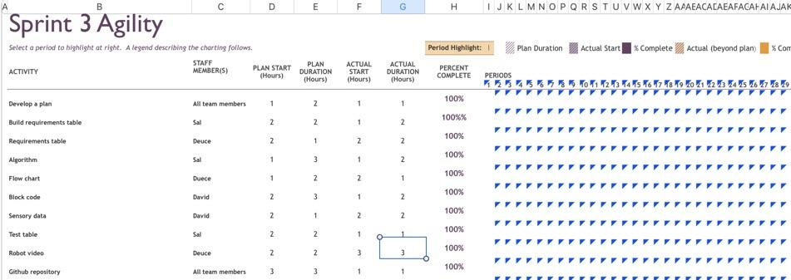

***Staffing Plan***

**Insert a chart/table that depicts the roles and responsibilities of each team member that worked on this project**

| **Name** | **Role** | **Responsibility** | **Reports To** |
| --- | --- | --- | --- |
| Sal | Logged all information into the charts and the document | Diligently checked the numbers on the code and the moved them to document | David |
| David,Sal | Trial and error process of the robot | Wrote the code and made observations | Deuce and Sal |
| Deuce | Recorded trial runs | Recorded all our trial runs until we completed the sprint accurately | Sal ,David |